Category .5e Shielded Keystone Jack

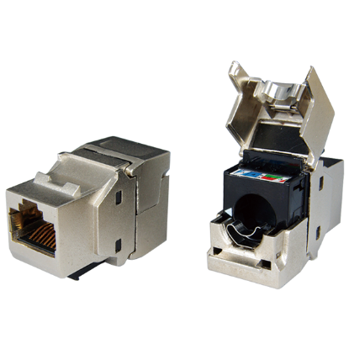

Category 5e metal-shielded keystone jack is designed for superior performance and easy assembly. Meets ANSI/TIA-568.2-D and ISO/IEC 11801 2nd edition Category 5e standard.

Features

Zinc-alloy metal shell

Contacts are phosphor bronze plated with 50 micro inches hard gold

Dual T568A &amp; T568B wiring

Polycarbonate 94V0 rated

UL Listed

Itertek ETL / Force EC Cat.6A VERIFIED

4PPoE compliant in accordance with IEEE802.bt Type 4

Ordering Information

|  |  |
| --- | --- |
| PART | Description |
| 1A58TPZe0 | RJ45, 8-Conductor Cat.5e, Tool-free, Shielded, 180 degree, H.D. version |
| 2A58KPSe0 | RJ45, 8-Conductor Cat.5e, KRONE/110 IDC, Shielded, 180 degree, H.D. version |
| 1K5800Se0 | RJ45, 8-Conductor Cat.5e, 110 IDC, Shielded, 90 degree |
| 2K58TPZe0 | RJ45 8-Conductor Cat.5e, KRONE/110 IDC, Shielded, 90 degree, Short depth design, L=29.86mm |